Advanced Manual
Documentation for
Teams and Workgroups
Version 1.0 for PC
by Kristi Winters and Martin Friedrichs (CS programmer)

(This page left intentionally blank.)

Contents
Welcome 5
Managing Users 6
Persons and users 6
User rights and abilities 7
Administrator rights and abilities 7
Add new User 7
Add new Person 8
Select a role 8
Edit a Person 8
Adding a new user to an existing project 11
Add a participant 11
Edit Participant 12
Managing projects 13
Organize your Projects 13
Add Project Folders 13
Organize Project 14
Project Basket 15
Open My Basket 15
Empty Project Basket 16
Alternative Target Variables Names 16
Syntax 18
Unmapped Harmonizations 18
Managing Your Work: Reports and Codebooks 20
Generating a codebook 20
Export Advanced Report (Codebook Option) 20
Workgroup reports 22
Database report 22
Search, Inspect and Compare Variables 23
Search and Browse Project Variables and Measurements 23
Compare Variables 24
Managing metadata 26
Import Metadata with DDI 3.1 26
Displaying variable Metadata 26
Display Variable information from the Basket 27
Literature 28
Comments 29
Multiple comments with subject support 29
Find and Replace 31
Graph 31
Change Color Scheme 31
Troubleshooting 33
Release Lock on Project 33
Revoke ‘Finished’ Status for a Project 33
Release Lock on a Variable or Attribute 34
Change Password 35
Database Connection 35
Communications Suite: MessangerManager and TaskManager 36
MessageManager 36
Open MessageManager 37
TaskManager 37
Open TaskManager 38
Edit Tasks 39
Priority Tasks 39

Welcome

Welcome to the Advanced Manual of CharmStats Pro. This manual describes additional features in your CharmStats Pro not covered in the introductory user manual: The features we cover were created to address the needs of research groups and institution, to support collaborative and group work, and to document the harmonization work in a sophisticated way.
The first section of this manual explains how to give people access to the CharmStats Pro software and assign them rights to contribute or oversee the harmonization work. The second section provides information on managing your project folders and using the My Basket feature. Other sections expand on the features available to you, such as advanced reports (codebooks), comparing variables, using metadata, advanced search and compare features, and information on the Troubleshooter rights to help you manage your work. Finally, we describe the MessageManager and TaskManager features of the Communications Suite: an internal communications system that allows members of a project to keep more of their work in the same place as their harmonization projects.
Thank you for your interest in our software. Please contact us on charmstats@gesis.org if you have inquiries.

Managing Users
In CharmStats Pro multiple users can co-operate on harmonization projects. This section describes how to create new users and assign users to projects. We also show you how to use other features designed for multiple users and how to link people, institutions or universities to a user account.
IMPORTANT: The person who downloads the software can access two default user roles: “user” and “trouble”. The usernames are ‘user’ (the password is ‘user’), and ‘trouble’ (the password is ‘trouble’). The default CharmStats “user” has the role of “Admin” and “trouble” provides access to all the rights and roles of a “Troubleshooter”.
Hint: Please change the password for both users as soon as CS Pro has been installed. To do so, start the CS Pro application, log in as “trouble” and call “Change Password” from the menu Extra | Troubleshooting.

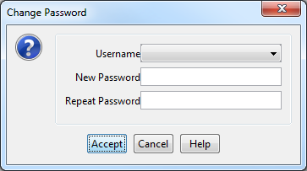
Select from the list of user names the user you want to change the password for. Enter the new password and repeat it. Leave the dialog by pressing “Accept”.
Repeat this for both “user” and “trouble” and you are set and done.

Persons and users
A ‘Person’ documents which individuals (e.g. a researcher) or institutions (e.g. a university group) are accessing CharmStats. Assigning them the various user roles gives them access to different parts of the CharmStats database. Persons are then assigned rights and abilities based on which roles are assigned to them.
There are three roles you can assign to a user within CharmStats Pro: Admin (administrators), User, and Troubleshooter. Once a User has been created they have the ability to: log in and out of the system, change their own password, search or browse projects in the database, change their own interface settings and make use of the workgroup support.
In the next step we show you how to assign the rights and abilities to your CharmStats Pro users.

User rights and abilities
Users may create projects and can edit project content.

Administrator rights and abilities
Administrators may create new users or edit existing users and persons. They also have the ability to import, edit and remove metadata from the database, as long as they have not been used in a project yet. For instance an administrator would be responsible for deleting duplicate variables imported into the database.
To create new accounts within CharmStats Pro, first select an existing person in the system or create a new person. Once a person has been selected or a new person has been created, the administrator can assign them their roles. It is possible to add the person’s (or research group’s) information at a later time in the ‘Add User Account’ dialog by clicking + Add Person, however best practices would start first by creating the ‘Person’.

Add new User
User Add new user. Only administrators (Admins) can create new users. Add new users to the system with the dialogue box (below). Select the person you are adding the user account for, give them a user name (this is the name the user(s) will enter when they log into CharmStats Pro), the role they will be assigned, and a preliminary password (users will enter when they log into CharmStats Pro and can change later). You will have to retype the password for confirmation purposes.
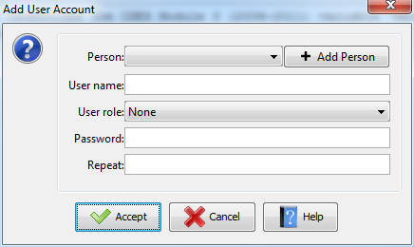
As mentioned above, users can be individuals, but accounts can be created to provide access to a research institution or university team. Add the relevant contact information for the new user name. This is the information you will need to change if a person is replaced as the contact for their institution.

Add new Person
Creating new persons and users gives them access to projects within CharmStats Pro. Each ‘User’ represents a single ‘Person’, but a ‘Person’ can be represented by multiple ‘Users’, depending for example on the ‘Role’ the ‘Person’ needs to fulfill. Enter information about users with the Add Person button or by clicking User Add new Person

Select a role
There are three different roles to choose from: Author, Editor and Certified User. If the person has a Certified User as their role they can be connected to a user account. If you are unsure you should always select Certified User. Author and Editor are used as metadata information in the Literature dialog form.
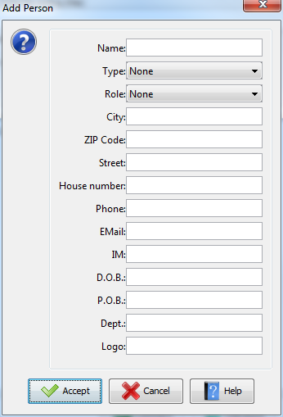
Edit a Person
Update or edit the information about a person or contact person for an institution by clicking User Edit Person. The dropdown box will display all persons in your database. Select the person whose information you want to edit and click Open.
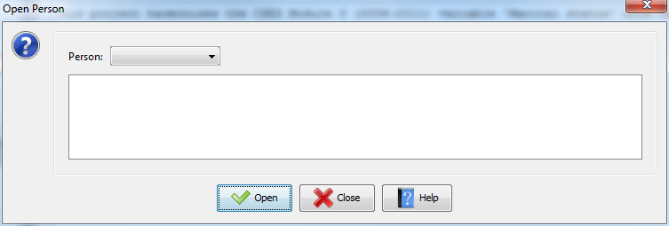
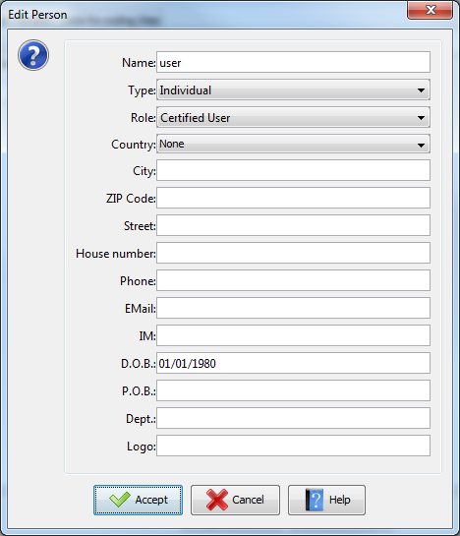

You may include as much or as little information as you like, including a link to an institution’s logo for use in the Report feature later on. To edit user information (such as the user name or password) use the Edit User feature. User Edit user
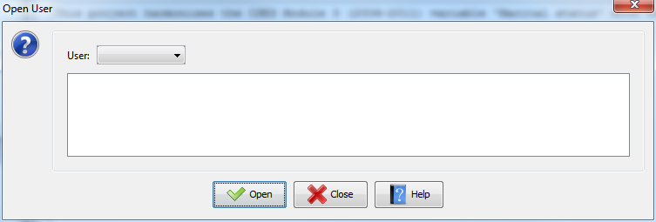
In the dropdown box you will see a list of all the users in your database system. You can edit information the window (below).
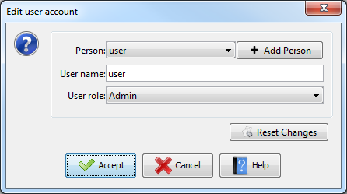
Note: A user can change his or her own password at any time, but if a user needs a password reset you cannot reset a user’s password using this window. Only the person/s who is/are assigned the role of Troubleshooter can change a password. For more on changing passwords see the Troubleshooting section in this manual.
Whether you assign a new account to a person on your team or as an access point to another institution please ensure you provide contact information for a person at that institution and update that information as needed.

Adding a new user to an existing project
Who can work on projects: The user who creates a project is immediately part of the team assigned to that project. CS Pro assigns all project creators the role of Project Owner.
IMPORTANT: Project owners have special administrative rights compared with other team members on the project. These special rights allow them to: add or edit project participants, remove or organize a project, change a harmonization project from unfinished to finished (editing is no longer possible). To add someone to a harmonization project you must assign them a participant role within the project.

Add a participant
The project owner has the ability to add members to the project team. Multiple users can be assigned to a single harmonization project and each new user can be assigned a different project participant role. To add people to your project, first open the project to which you want to add a participant. Then click Project Add Participant.
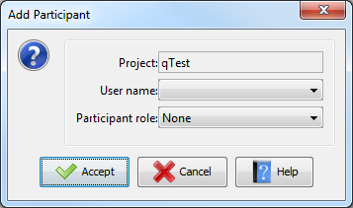
Other users in the project are called Participants. The rights and abilities assigned to a participant can be edited by the project owner and these role (and rights) can be changed by the project owner at a later time. This can include assigning the role of project owner to another user or removing someone from the list of active project participants: IMPORTANT: For documentation purposes they remain in the associated project metadata (but not listed in the report outputs) as being a “Former Member” of the project.
Project owner: All editor rights plus participant management and the project status (unfinished or finished).
Editor may open, edit or save a project.
Former team members: No access or rights. Participation noted in the project documentation.
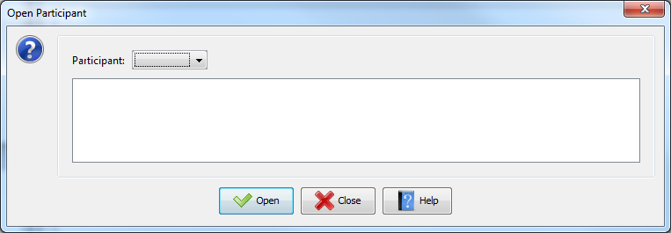

Edit Participant
To Edit Participant information later, the project owner should click Project Edit Participant
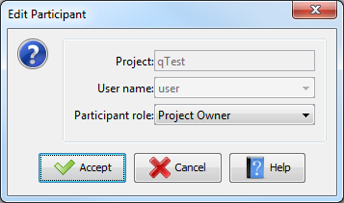
As an example, a CharmStats Pro administrator could facilitate collaboration on a harmonization project by creating a single User account for three academics based at a university. The first step would be to create a new User with the role of User. The Admin would then click Add Person and enter the university’s name and assign it the Type of ‘Institute’ and the Role of ‘Editor’. Finally, the CharmStats Pro administrator would open up the project the academics will work on and add the university user account to the project as an ‘Editor’.

Managing projects
CharmStats Pro allows multiple users to work on the same harmonization projects on a shared database. It gives you more flexibility to organize your harmonization projects by allowing you to create your own named folders and the ability to move projects between named folders.
This Project Management section reviews how you can organize your work within CharmStats Pro and how to add and organize team members and their work. We will first show you how to organize your projects, then review setting up your team for work inside CharmStats Pro and finally how team members can support each other.

Organize your Projects
CharmStats Pro allows users to create group folders where work can be organized by year, study, or any other category that suits and sort projects into folders that you name according to your data management needs. In addition to searching for variables and measurements, you may also search for Projects then move them to your Basket to open them when you want.
IMPORTANT: To create a new project folder you must first open an existing project or start a new project. The options to Add Project folder and Organize Project are only activated if a project is open.
IMPORTANT: Only a project owner may assign a project to a new folder. Learn more about project owners in the next section.

Add Project Folders
To create new folders to store your project, first open a Project. Project Create a New Project OR Open Project. After opening or creating a new project, add a new folder by clicking Project Add Project folder. Type in the folder name of your choice. No other metadata is connected to this folder, therefore you should make the project name something that is clear and understandable to everyone who will share the database.
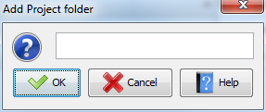
Once you have created your new folder you can move files 1) from the Unfinished folder to a named folder or 2) between name folders. Once you assign a project to a new folder it will be shown under that folder in the project window. To move a CharmStats project from a named folder back to the General projects folder select the “empty entry” in the Organize Project Dialog.
IMPORTANT: Because Project Folders can be shared between users they cannot be deleted by any single user. Create new projects only as needed.

Organize Project
A project can be housed in one folder at a time. To add projects to a new folder you have created, click Project Organize Project The dropdown list will include each named folder you have created. Select the name of the folder you want to shift your project to and click OK.
IMPORTANT: Moving a project to a named folder works on a global level. That means that the changes will be extended to any other users who have rights to work with that project.
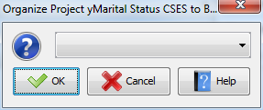
In the picture below, the qTest project was moved to the General folder and the pTest project was moved to the Example folder.
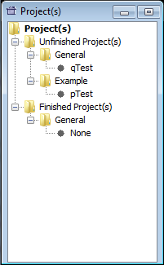

Project Basket
Users have the option to use either the default Temp Basket or My Basket when storing the results of the Search feature. The Temp Basket (temporary basket) holds information for the length of your CharmStats session. Once you log off as a User the Temp Basket is emptied of all information.
The My Basket feature allows you to save variables for work across multiple sessions. To switch from the default ‘Temp Basket’, click on Basket in the menu bar. The Temp Basket will be replaced with My Basket. Source and target variables saved here will be stored after your session has ended and can be retrieved by opening My Basket again.
Once My Basket has been open other features in the menu dropdown become activated. You can click Close My Basket if you want to return to using the Temp Basket. You can update the list of variable stored to your basket by clicking Save My Basket. To clear the list of variables you have stored to My Basket, click Empty My Basket.

Open My Basket
To open up the My Basket feature click Basket Open My Basket.
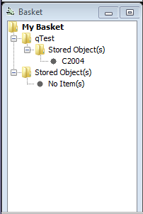
In the My Basket window, double clicking on the folder name will open up a new Forms window that displays the information contained in the folder.
While working in the Temp Basket or My Basket window, you can inspect all the metadata connected to the variables and measurements you are working with by double clicking on the item. The Forms window will display the metadata. You cannot edit information in this window, but you can review it as shown in the View only example below.

Empty Project Basket
The Project Basket can be emptied when you have finished your work and are ready to move to the next harmonization project. First open the Browser view of the Project Basket then click Basket Empty Project Basket.

Alternative Target Variables Names
Additional metadata have been added to the CharmStats Pro data model. Alternative naming / labeling of target variables was added. In case some your target variables require unique variable names. To change a target variable name and label click the ‘Alternative’ button on the Target Variable tab in the workflow.

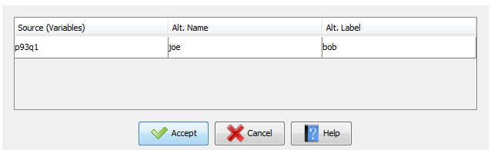
This window will open. If you fill in the information in this window it will be stored with your project’s metadata. When you run your harmonization syntax the original label will appear in the fields, however the alternative label will appear in the syntax. I used the rather unusual name and label to make them easier to spot in the code below.
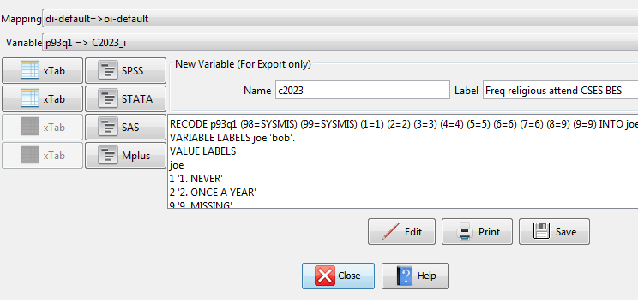
Sampling level:
For those who are working with multi-level models and need to differentiate between micro, meso and macro variables, it is now possible to indicate which variable is the meso level variable.
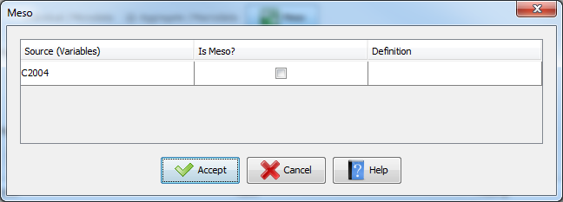

Syntax
CharmStats products allow users to store or generate harmonizations using the language of several proprietary statistical packages. CharmStats Pro allows users to generate syntax for SPSS, Stata, SAS and MPlus. In addition, as we knew many researchers would want to visually inspect their original and recoded variables, we have also created the ability for users to add a cross tabulation command to their data. This feature adds the syntax command to create a 2x2 table using your original and newly harmonized variables in your outputs.
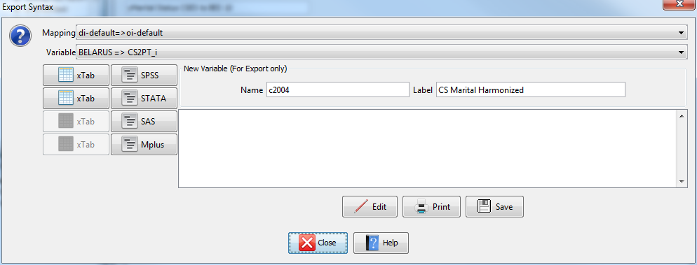

Unmapped Harmonizations

For some users the recoding of one response option into another is insufficient. To help document syntax code on based on mapping response options, there is an alternate way to document your data recoding. You can store already existing syntax code within your documentation.

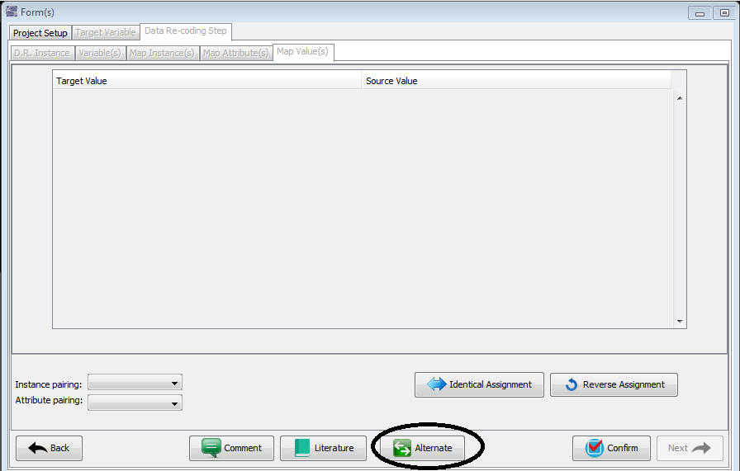
On the Data Re-coding Step click the button Alternate and you are redirected to this screen:

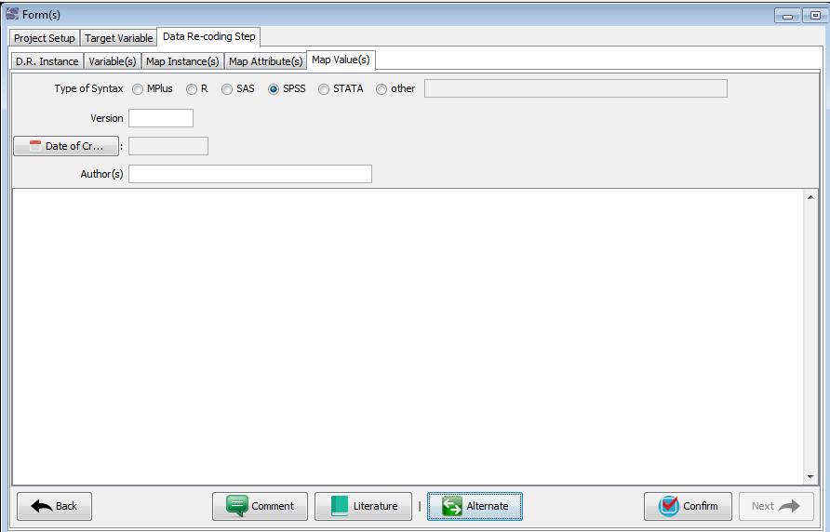of

Use the text field to paste your syntax into the workflow. Any syntax code or notes you’ve written will be included in your final documentation. If you use this window your report will not include a graph of the variable harmonization and the code cannot be translated into other statistical syntax languages.

Managing Your Work: Reports and Codebooks

Generating a codebook
The Report generator offers new options to select from, compare with QuickCharmStats. First, a new template has been added to make it easier to submit finished harmonization projects to Datorium for peer-review. Second, more keywords have been added to access project content added. Finally, a “Refresh” button was added.
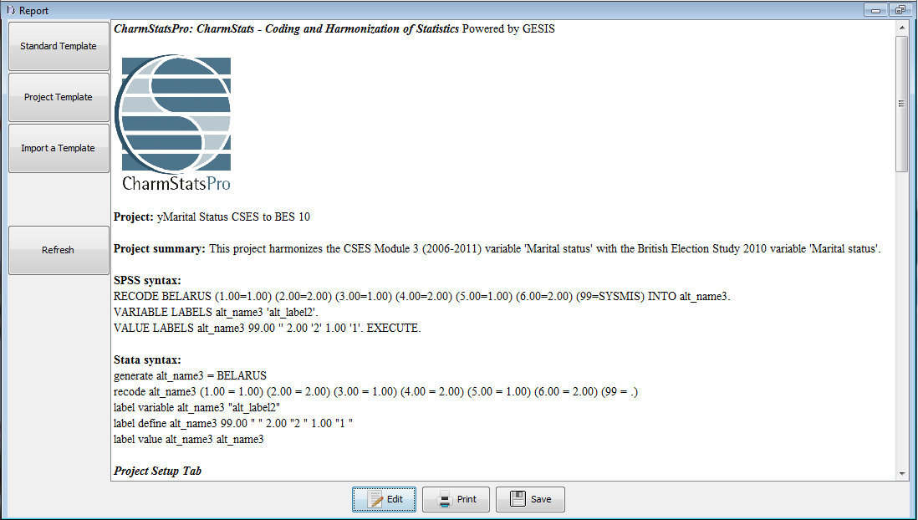

Export Advanced Report (Codebook Option)
In addition to the standard report CS Pro offers the Advanced Report feature that generates codebooks: the creation of a mass report that displays the information from multiple projects simultaneously. An Advanced Report allows the user to combine the result of multiple harmonization projects into one document. With this command a report containing data from multiple projects can be created, the so-called “codebook option”.
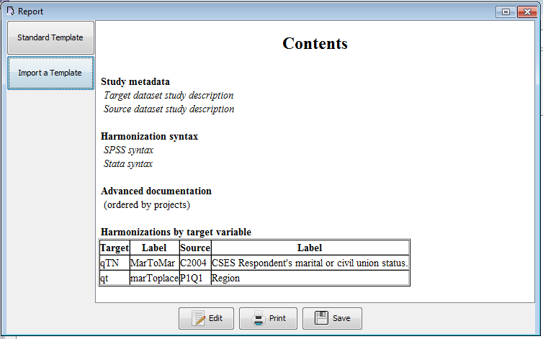
To create a CharmStats Codebook got to Data Export Export Advanced Report from the menu. This opens a dialog where you can select the projects you want to combine:
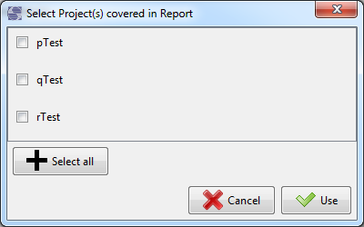
The following dialog will be opened:
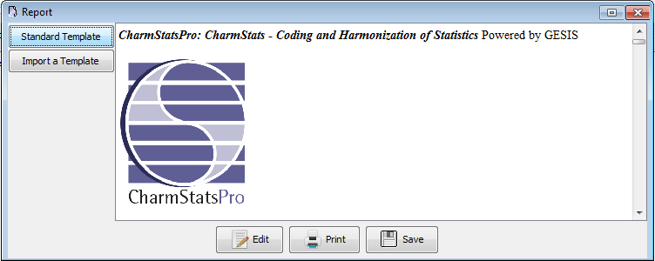
You may now select the report you want to fill with content from multiple projects.

Workgroup reports
Within the CharmStats Pro database an activity log records and stores any changes to projects. This list is updated, processed and a report is created each time a user logs into the program. Only changes done by other users are listed.
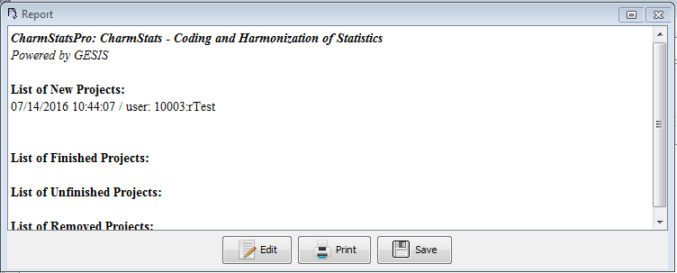

Database report
Any additions or changes variables and measurements and their metadata (question and study level information) are documented in Database reports. When a user logs in, the system checks if any information has been added or changed since the last time the user connected to the CharmStats Pro database. Only changes done by other users are listed.
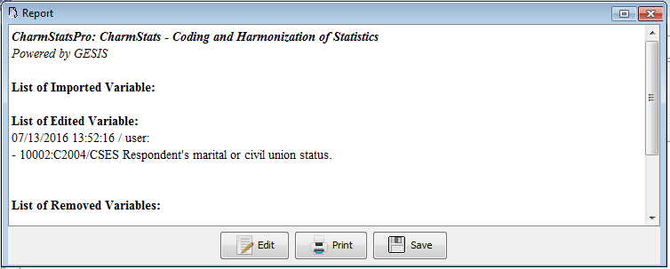

Search, Inspect and Compare Variables
It is possible to look at an overview of all the variables and measurements contained within your CharmStats Pro database. A detailed view for each entry in the browser is generated. To generate this information, click Search Browse Variable(s)
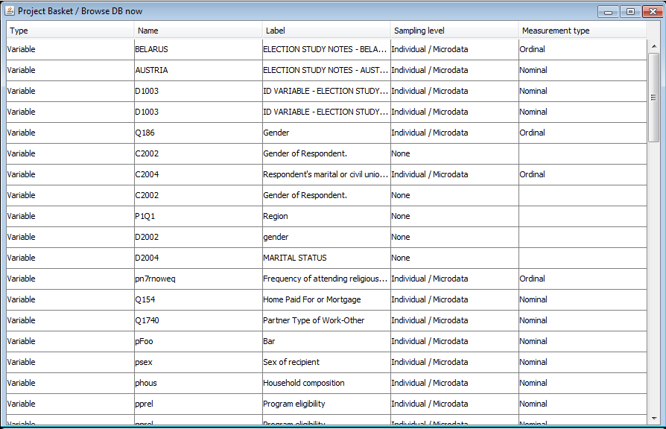

Search and Browse Project Variables and Measurements
It is also possible to look at an overview of the variables and measurements contained within a specific harmonization project. Open the Project you want to examine. To generate the variable information for that specific project click Search Browse Variable(s) in Project scope.

Compare Variables
For users who want to compare variables before using them we have created a new Compare Variables function. To compare variables first use the Search Variables tab for the variables you want to compare and add them to your Temp Basket or My Basket.
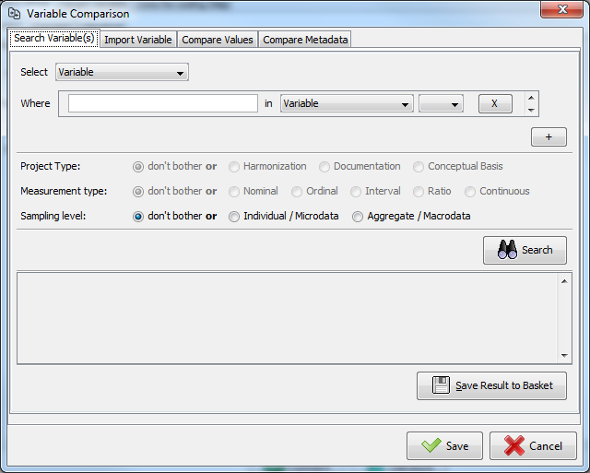
Use the Import Variable tab to select the variables from your Basket that you want to use in the Compare Values tab. Measurements will be imported as the default comparison.
The Compare Values tab allows you to compare the value and labels of a measurement variable to a source variable. The save button saves your all the work you’ve done in Compare Metadata.
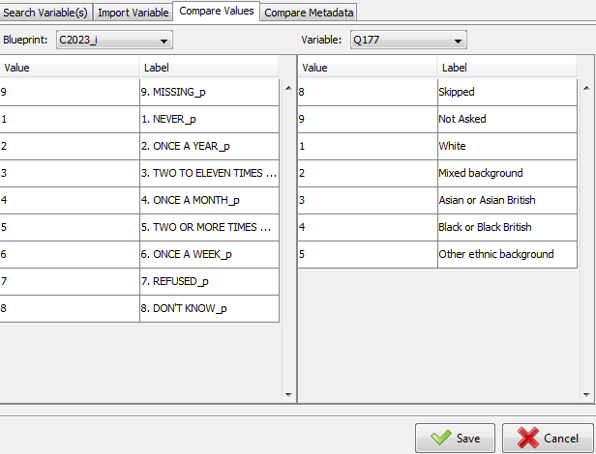
The Compare Metadata window allows you to review the metadata you imported or hand-entered for each of the variables you are comparing.
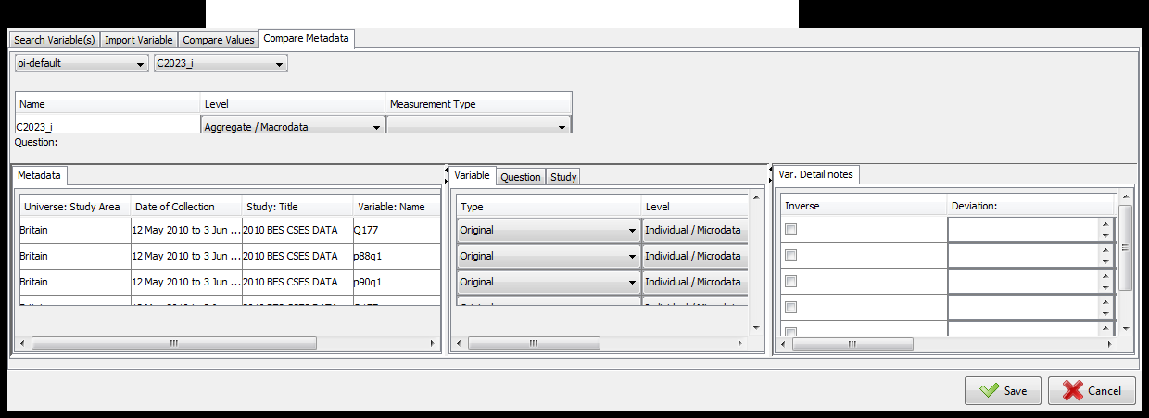

Managing metadata
A major advantage to using CharmStats products is the ability to store information about a variable at different levels including variable metadata, question metadata and study metadata. The ability to store extensive amounts of metadata isn’t much help if it cannot be easily accessed or displayed. In this section we present several advanced features for importing, browsing and managing them are presented.

Import Metadata with DDI 3.1
CharmStats Pro supports importing variable and measurement metadata using DDI 3.1 xml files. In two instances you will be able to access DDI 3.1. Data Import Import Variable and Data Import Import Measure. Data imported will include variable level metadata, question level data and study level data so long as DDI 3 offers that specific metadata or the user adds it themselves.
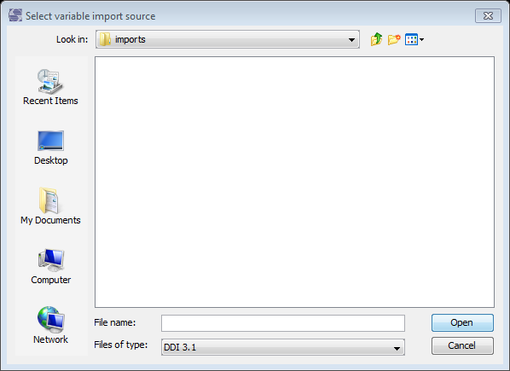

Displaying variable Metadata
We understand that large scale or longitudinal data teams need to review large numbers of variables across several studies. CharmStats Pro helps you inspect various levels of metadata in your database. To review the variables you are using inside a project from within the Forms window, click Data Recoding tab Variable(s) tab
Select the variable to bring up a new window with its variable level, question level and study level metadata.
IMPORTANT: You cannot edit the information in this window. If you find errors or want to make changes, click Data Edit Variable/Measurement.

Display Variable information from the Basket
To inspect the variables that are saved to your basket from within the Forms window, double click the variable you want to review.
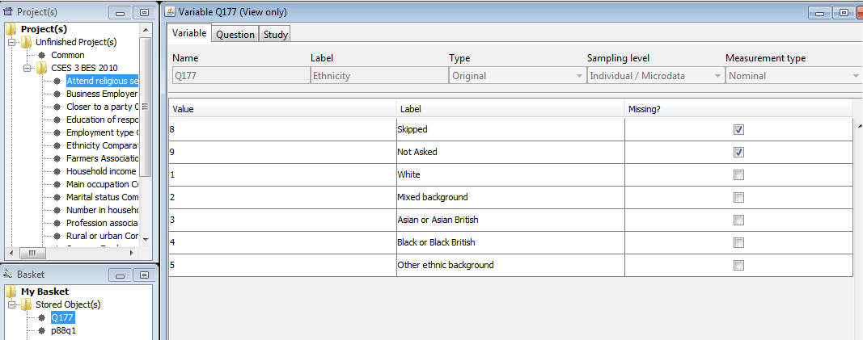

Finding ways to make documentation quicker and easier is the ongoing goal CharmStats products. In this next section we review several new features that we hope will facilitate a full documentation of variable harmonization work: the Literature tab and extended Comments. Also reviewed is the new Find and Replace feature that helps you find and/or correct information in your projects.

Literature
Bibliographic information on the literature relevant to your variable harmonization can now added to the CharmStats database. Literature reference can be connected with the project, with each step in the workflow, with variables and measurements. Stored Literature references can be searched for and re-imported into other projects, meaning that once a member of a team enters the literature information all other members will be able to find it and cite it themselves.
Select the option ‘Literature’ from the Search Selection dropdown. Run the search and select the literature you want to save, just as you would a target or source variable. Import the literature metadata into a new harmonization project by selecting Import Lit.
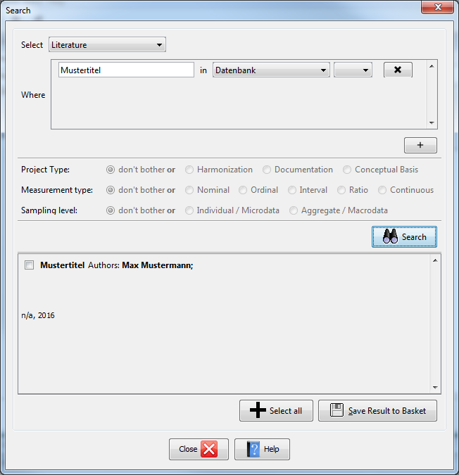
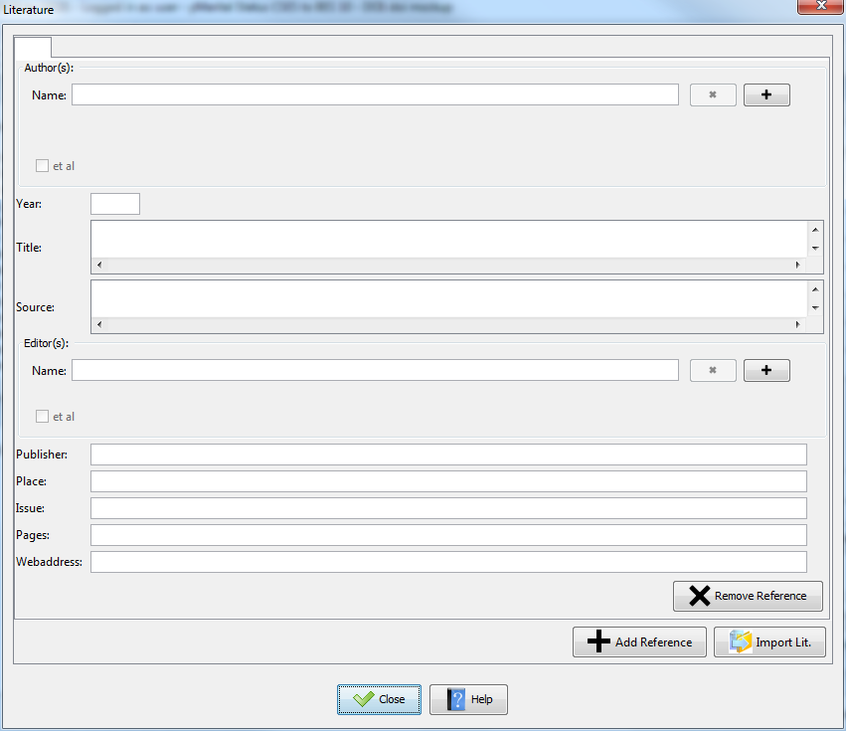

Comments
Comments are a main source of documenting coding decisions in CharmStats. Comments allow researchers to include important notes, comment on the problems they faced or provide a rationale for the coding decisions they made. The improved CharmStats Pro comment editor allows for more specific, and therefore finer granulated, documentation. The Comment feature was further upgraded to allow for more than one comment per object.

Multiple comments with subject support
In CharmStats, comments describe or explain a specific subject concerning the object of comment. In Pro, so-called “Subject comments” have been added. Multiple comments for each object are supported. The Subject Line can come from controlled vocabularies, allowing comparable standards in documenting the harmonization.
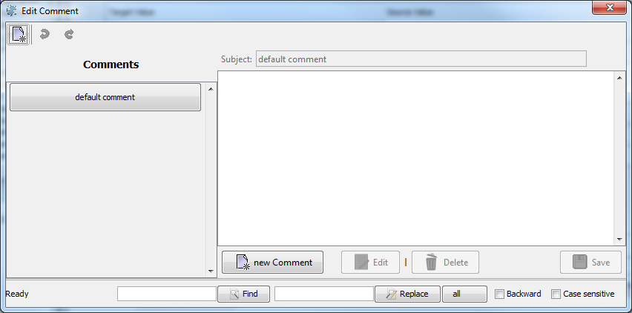
You may review an overview of all the comments contained within a specific harmonization project. Open the Project you want to examine. To generate the comment list for that specific project click Search Browse Comment(s) in Project scope.
It is also possible to inspect an overview of all the comments attached to all projects contained within your CharmStats Pro database. A detailed view for each entry in the browser is generated. To generate the information click Search Browse Comment(s)

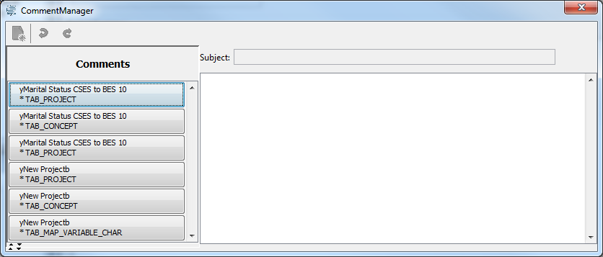

Find and Replace
Users can enter a word into the Find window in order to find that word in the selected text field or area only. It is also possible to replace words in the text field or area in which the user is searching.

Graph
The Graph view will be familiar for users of QuickCharmStats, but our Pro version offers new options . One new feature allows users to insert their definitions and comments into the graph area. To activate this, check the Show Definition(s) or the Comment(s) Box.
A new “Prepare Report” button has been added. This feature creates connections between your graphs and project reports by saving a graph, named correctly for the template formats used by CharmStats, for use in a report. Select the Target:Source graph first, then press the Prepare Report button.

Change Color Scheme
With this command you can change the color scheme used for the objects in the Graph view The color scheme is stored as each user’s personal set up, therefore if a team wants to use a color scheme to brand their graphs then each user must make the changes to their preferences individually.
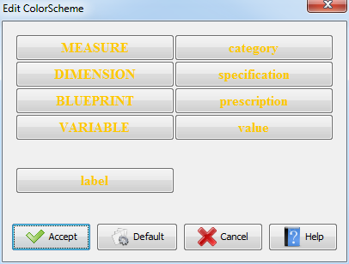

Troubleshooting
The troubleshooter’s rights are limited to managing and helping users do their work. Only someone assigned the rights of Troubleshooter can access the Troubleshooting menu.

Release Lock on Project
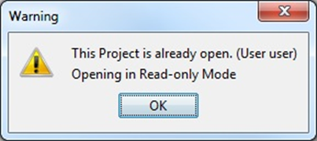
To prevent multiple people from working on the same project simultaneously only one user at a time may edit it. Projects are locked in the database when a user opens it and after closing the project the lock is removed. In case of a problem that results in your project unexpected ending, sometimes the project remains locked in the database. We will walk you through the steps that correct the erroneous lock and allow you to access it again as a user.
To remove the lock on a project select Release Lock on Project from the menu Extra | Troubleshooting. The ‘Release Lock’ dialog opens. Select the project to be unlocked from a combo box list. Each entry in this list names a project and the user editing it. Press the button “Accept” to complete the process.
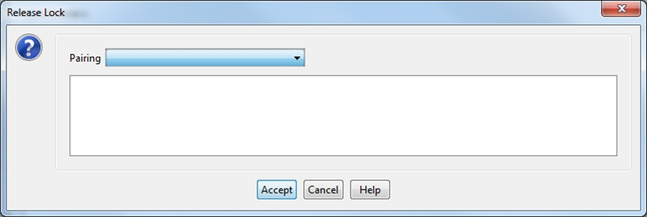

Revoke ‘Finished’ Status for a Project
When you use the command ‘Finish’ on a project it is then closed for editing. In the CharmStats Pro version, projects that are finished can be seen by everyone using the database. If a user accidently changed a project’s status to finished, the Troubleshooter may revoke the finished status of a project and make it a working project again.
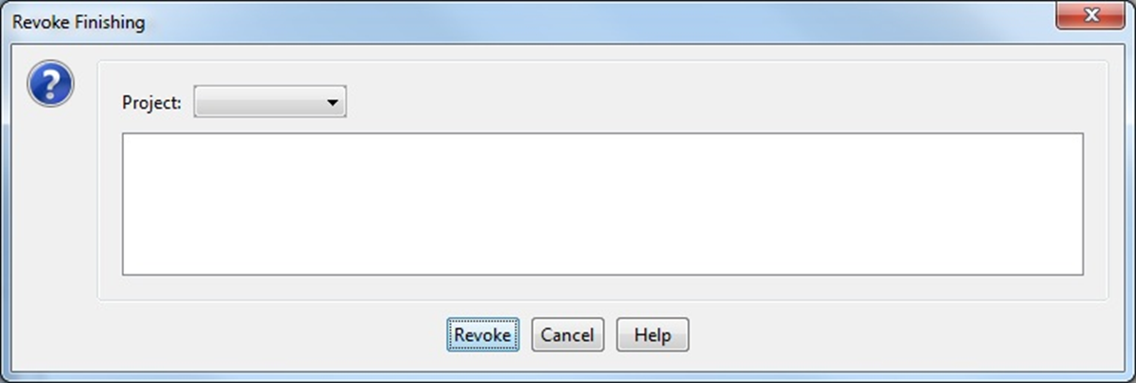
First, log out as a User and login in as the Troubleshooter To ‘unfinish’ a project and make it open for editing again, a troubleshooter first has to add the project to the basket. Using the Search function, search for the finished project and store it into the basket. Next use the command Revoke Finish from the Menu Extra | Troubleshooting. In the dialog box that opens, select the project to be listed as unfinished from a combo box list. Press Revoke Finish to complete the process.

Release Lock on a Variable or Attribute
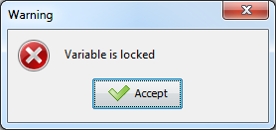
Attributes of a variable or measurement are locked in the database after opening in an editor. To prevent multiple people from working on the same attribute only one user at a time can edit them. After closing the editor, the lock is removed. In case of a problem that results in an unexpected shut down, the attribute remains locked in the database. We walk you through the steps that allow you to access it again under as a user.
To remove the lock on an attribute select Release Lock on Attribute from the menu Extra | Troubleshooting. The ‘Release Lock’ dialog opens. Select the attribute to be unlocked from a combo box list. Each entry in this list names an attribute and the type (variable or measurement) of it. Press the button “Accept” to complete the process.
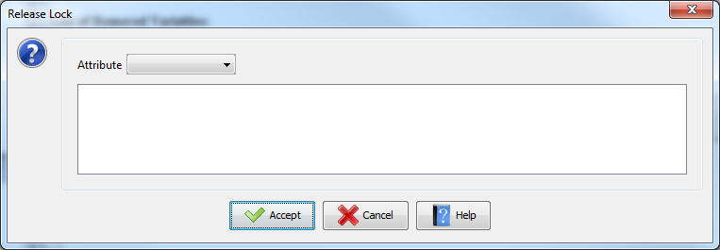

Change Password
A troubleshooter can reset a user’s password without knowledge of the old password. Select Change Password from the menu Extra | Troubleshooting. Next, select the user whose password is to be changed and enter a new password for that user. Press “Accept” to complete the process.
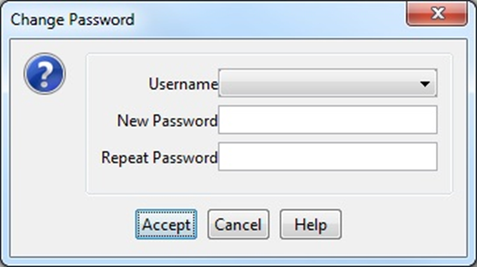

Database Connection
By default the connection of CS Pro is preset to access a localhost db named charmstatsx using a db user account called charmstats_user. Switching the access to a database server, or a to a alternatively named database is handled by calling the Reset DB Connection dialog.
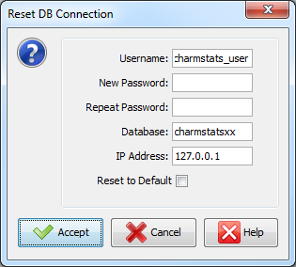
You have to enter the database user account for CharmStats and the password followed by the database name and the IP Address of said database.

ed DATABASE SERVER

Communications Suite: MessangerManager and TaskManager
Teamwork requires the exchange of information between different members of a team and the archiving of important information. The MessageManager is a build-in tool to support these activities. These features were included to help centralize all the relevant communications and tasks associated with creating, editing and publishing harmonization projects within the software. It works similar to an eMail client and is designed to allow users to send messages to other accounts within the database. CharmStats Pro also includes a connected TaskManager feature to help users organize their work.
Rather than team members communicating with an external email service and maintaining their ‘to do’ lists there, all relevant communications can take place within CharmStats Pro and are maintained on the software’s database. This ability to centralize task assignments, questions and advice between team members, and convert messages into actionable tasks enhances a team’s ability to document its own work in a way is unlike other software packages.

MessageManager
Users may send messages to other users in the connected CharmStats database, forward messages or respond to internal messages from other users.
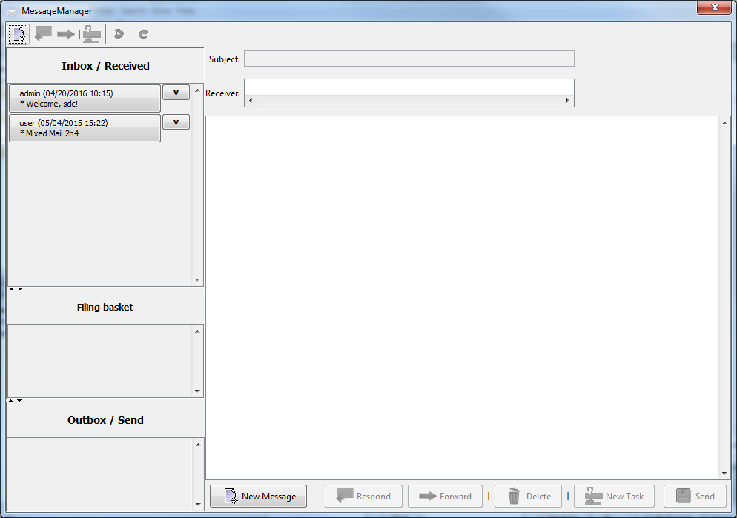

Open MessageManager
To access MessageManger click Extras Workgroup Support Open MessageManager Use the New Message tab at the bottom of the form or the New Message icon in the top right-hand corner to create a new message. Give your message a Subject line. Next enter the receivers for this message: Users or projects can be listed. This process is supported by auto-completion.
Received messages are displayed in the Inbox/Received window. The Filing Basket is used to store already-read messages. Move a message from the Inbox to the Filing Basket by pressing the „v“ button to the right of the message. Move a message back by pressing the „^“ button right of the message.
To delete a message it has to be in the inbox first. Open the message. The button Delete in the Toolbar below the edit window gets enabled. Press the button, confirm the command. The subject line changes to red and the message will be removed after closing the window.Copies of the messages you send to other users are kept in the Outbox/Send window.
Messages can be transformed into tasks. Use the New Task icon on the bottom right-hand side of the window. When you click this button the TaskManager dialog will open. Subject and message are fetched from the message. You may freely switch between both windows.

TaskManager
To help users organize their work the CharmStats Pro Communications Suite includes a task manager feature where users can organize their workflow.
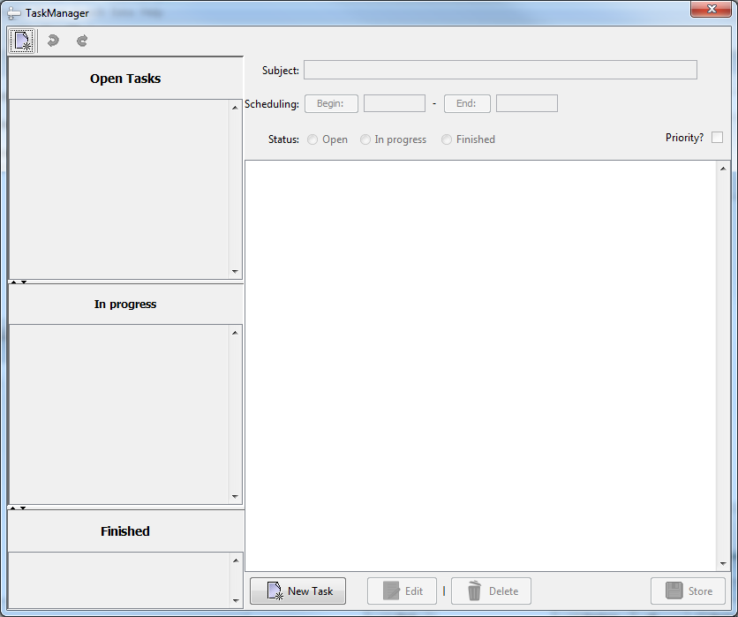

Open TaskManager
To access TaskManger click Extras Workgroup Support Open TaskManager The TaskManager can also be opened by pressing the TaskManager icon from the toolbar. This icon is only visible if there are open tasks and is placed at the right edge of the application
To add a new task, click the New Task button at the bottom of the window or the New Task icon in the upper left-hand corner. Give your task a name by typing it in the Subject area of the window. Use the Begin and End buttons to give the task a start and end date using the calendars that pop up when you click them. Write notes, copy external links or include other textual information in the main window. Click Store to save your task.
Move an Open Task to an In Progress Task by clicking on the down arrow next to each named task. Move them back into Open Tasks by clicking on the up arrow next to each task in the In Progress area. You may also move tasks between the windows using the buttons Open, In Progress, Finished within the task itself.

Edit Tasks
To edit a task, first double click the task to open it. It will open in an uneditable format to prevent accidental changes to the content. Click the Edit button to activate all the content in the task. Click Store when you have made your changes.

Priority Tasks
At the time of creating the task you can chose to make it a priority and it stays until bolded in the list until the task is deleted. There is no current way to change a task from priority to non-priority.

XMLBeans technology is used

